BOT BRAIN ASSIGNMENT (EAI201)
Shankara Vasishta T N
B.Tech CS&AI 24UG00541
Week 1: Project Understanding & Planning:
Project Title: CU_path_Finder
Abstract:
This project includes mapping out different buildings in the Chanakya University campus with the path to each building including the distance.
This code will help anyone find the shortest path between 2 different buildings/locations within the campus.
Multiple search algorithms will be implemented with this model.
All of this will be integrated with a user interface.

INTRODUCTION:
Campuses are often large, filled with buildings with multiple paths to a building and sometimes with constraints like a one-way road.
This project focuses on finding the shortage path between 2 locations within the Chanakya campus.
To implement this project, different search algorithms (BFS, DFS...) will be used and a map of the campus will be mapped.
A total of 12 location have been mapped and surely many paths exist for travelling from one to another.
PROBLEM STATEMENT:
One might not know the path from one location to another within the campus or might not know the shortest path.
OBJECTIVES:
To make an path finding intelligent agent for the Chanakya university campus which will return the shortest path from one location to another.
To implement different search algorithms and also to integrate a UI .
To use Google mas API.
SCOPE:
To develop a fully functional AI agent that is trained to give the shortest path to the user between two locations in a University campus and help in Navigation.
(This project although might not be very useful for students to travel as they already know the shortest path, It might be very useful for any Robots or Travel dependant machines in the future….
or maybe we develop our own SELF-DRIVING BUGGIE CART that travels by itself around the campus using this AI agent)

Mapping and Tools used:
I have included 12 locations for this project
namely:
1 Academic block A / Admin block
2.Academic block B
3.Main hostel
4.Library
5.Crikcket ground
6.Cafeteria
7.Food court
8.Sports complex
9.Main Gate
10.Auditorium
11.Faculty housing
12.Mart
The distance between each location is measured on GOOGLE EARTH
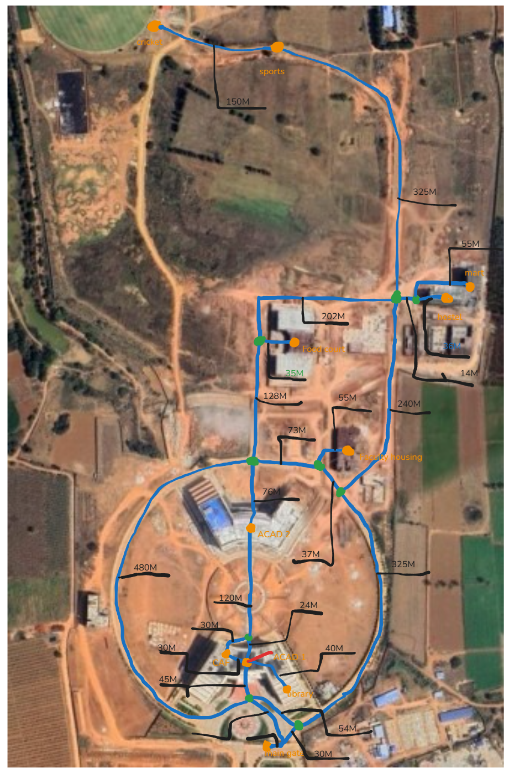
The above MAP contains the path network with locations and distance in between
LEGEND:
- Junction
- Location
- Pathway

Tools/Technology list:
1. Google Earth
2. Python
3. Rasa/ Dialogflow
4.
WEEK 2:
NLP:
The natural language processing will be a set of words that includes
{destination, origin, from, to, by, take ….. etc}
other words which are non-relevant to travel will be invalid inputs by the user .
3.Navigation/Pathfinding (Google Maps API / campus map):
I have made my own map with locations, junctions, route and distance.
My map was used by AI as reference to make the graph

WEEK 3&4:
Integration of navigation and making UI .
Path was made with reference to my map.
Final integration of backend with UI
testing of distance and calibration of distances .

SYNOPSIS:
Introduction
The CU Campus Path Finder is an intelligent navigation system designed to help students, faculty, and visitors find the shortest and most efficient routes between different campus locations. The system integrates an interactive map-based user interface with advanced graph search algorithms to ensure accurate and user-friendly navigation.

Objectives
- Provide an interactive campus map with zoom and pan functionality.
- Enable users to select start and destination locations easily.
- Support multiple search algorithms (BFS, DFS, UCS, A*) for pathfinding.
- Highlight the shortest route visually on the campus map.
- Display distance, estimated walking time, and nodes explored.

System Architecture
The system is divided into three layers:
- UI Layer (map_ui.py)
  - Built using Tkinter.
  - Displays the campus map (50% of screen).
  - Sidebar (50%) with dropdowns for locations, algorithm selection, and output details.
  - Handles user interactions, zooming, and panning.
- Backend Algorithms (pathfinding.py)
  - Implements multiple pathfinding algorithms:
    - BFS (Breadth-First Search)
    - DFS (Depth-First Search)
    - UCS (Uniform Cost Search)
    - A Search*
  - Computes the shortest path based on user choice.
- Data Layer (campus_graph.py)
  - Stores campus graph as adjacency list with distances (in meters).
  - Contains normalized coordinates for rendering nodes and edges on the map.

Features
- Interactive map display with real campus layout.
- Colored markers for key locations (Library, Hostel, Cafeteria, etc.).
- Junction modeling for accurate routing (e.g., hostel fork).
- Multiple pathfinding strategies to compare results.
- Real-time path highlighting on the map.
- Zoom & Pan synchronization (map and routes scale together).

Benefits
- Helps new students/visitors navigate the campus easily.
- Provides shortest and alternative paths using different algorithms.
- Demonstrates practical application of AI search algorithms.
- Modular design allows future integration with GPS or mobile apps.

Conclusion
The CU Campus Path Finder successfully combines graph-based search algorithms with an interactive map interface to deliver an efficient campus navigation tool. It not only improves accessibility but also acts as an educational demonstration of AI algorithms in real-world pathfinding problems.

